There may exist multiple regular expressions to denote a language. However, the regular exp must not contain any string that is not part of the language.

Construction of an NFA from a regular expression

Consider 2 REs r1 and r2. Now we can construct 2 NFAs m1 and m2 correspondingly. Then the language

L(r1 + r2) can be represented by m1 + m2

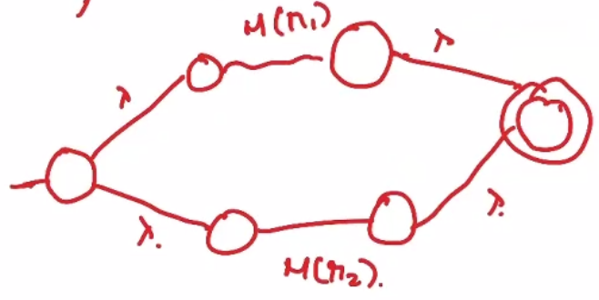

DFA from a regular expression

First convert RE to NFA. Then convert NFA to a DFA.

Regular Grammar

A grammar is defined by a 4-tuple,G = (V,T,S,P).

G is said to be right-linear if the productions P are of the form

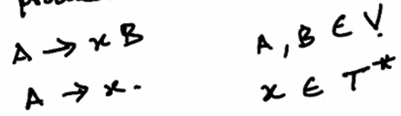

i.e. 0 or more combinations of terminals

G is said to be left-linear if the productions P are of the form

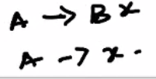

A regular grammar is one that is either left- or right-linear.

Eg

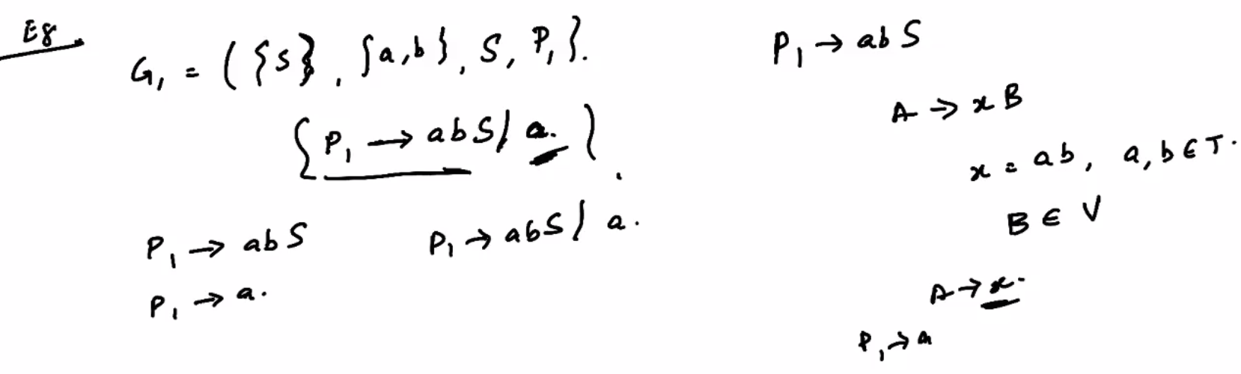

Here the grammar G is right-linear, as the productions are of the form A -> xB

Eg

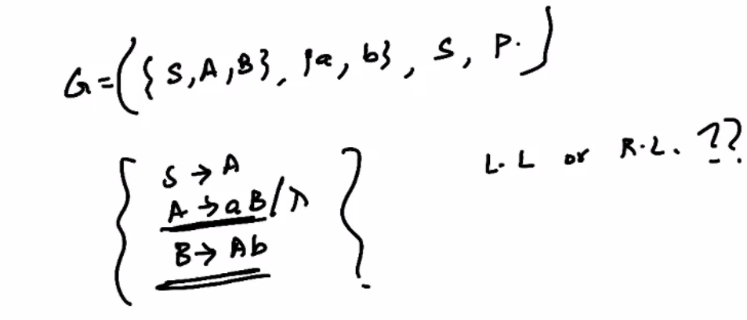

Here, we have 2 productions, one which is left linear and the other is right linear. Hence this grammar is not regular.